EMPLOYEE MANAGEMENT WEB REST APPLICATION

1. **Add Roles Dynamically in the database**

Fetching and Creating roles are available in the endpoint

<http://localhost:8081/api/roles>

Two Roles are being added as shown below:

USER and ADMIN

Creating roles using POST

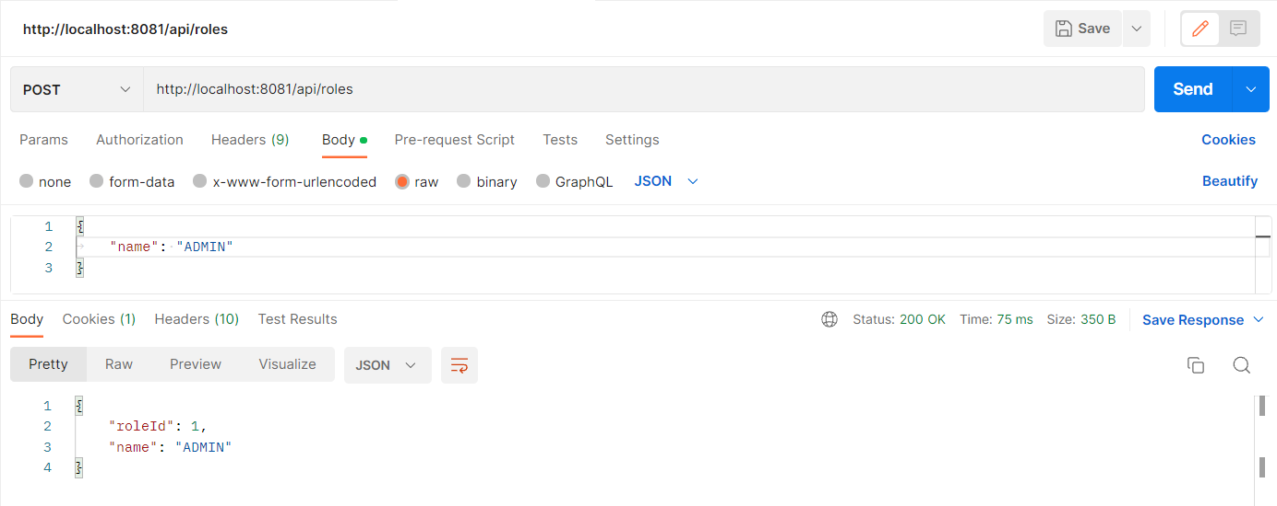

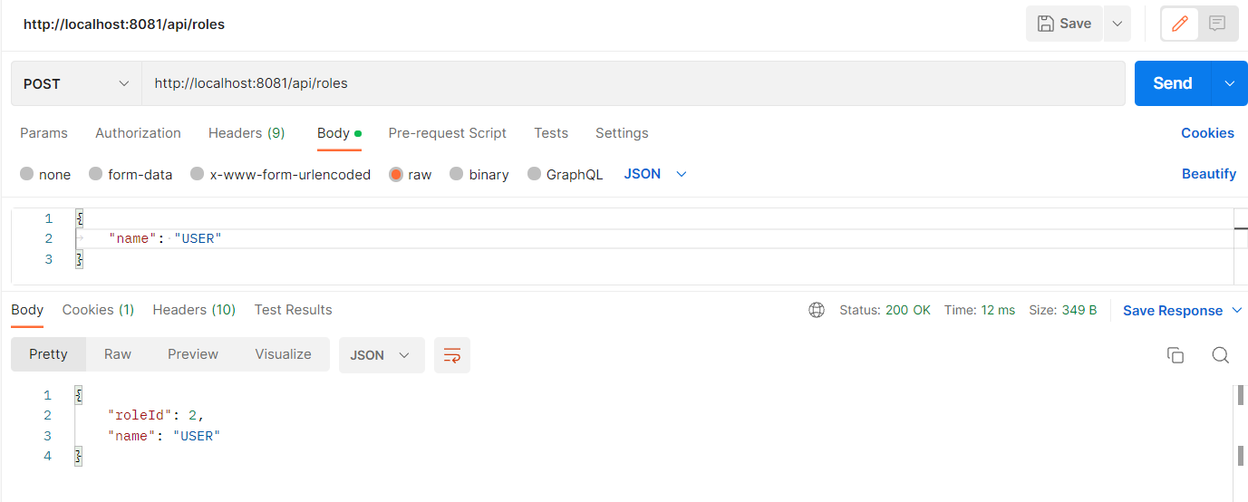

Fetching Roles using GET Request

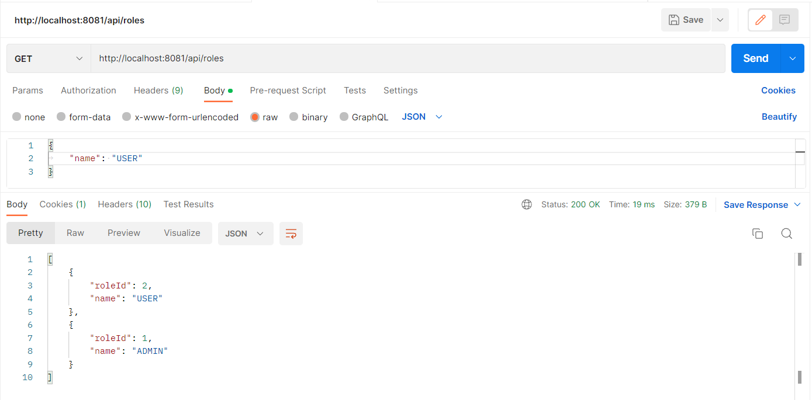

1. **Add Users in the DB dynamically**

The fetching and creating of Users are available in the end-point

http://localhost:8081/api/users

Adding a User with USER role

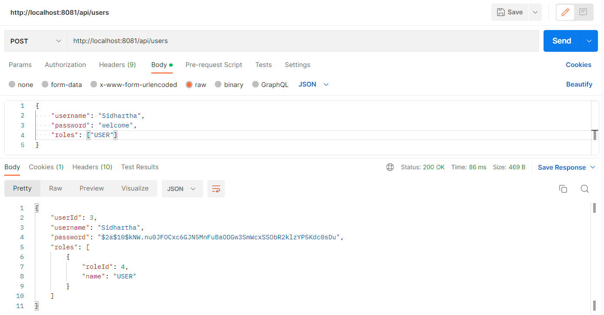

Adding a User with ADMIN Role

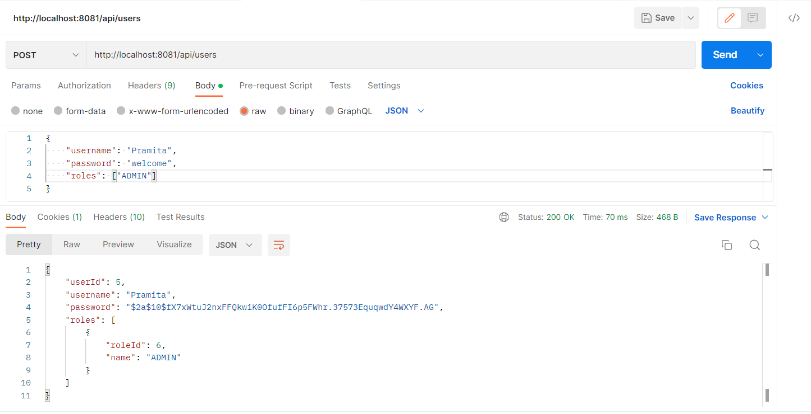

Fetching the Users using GET Request

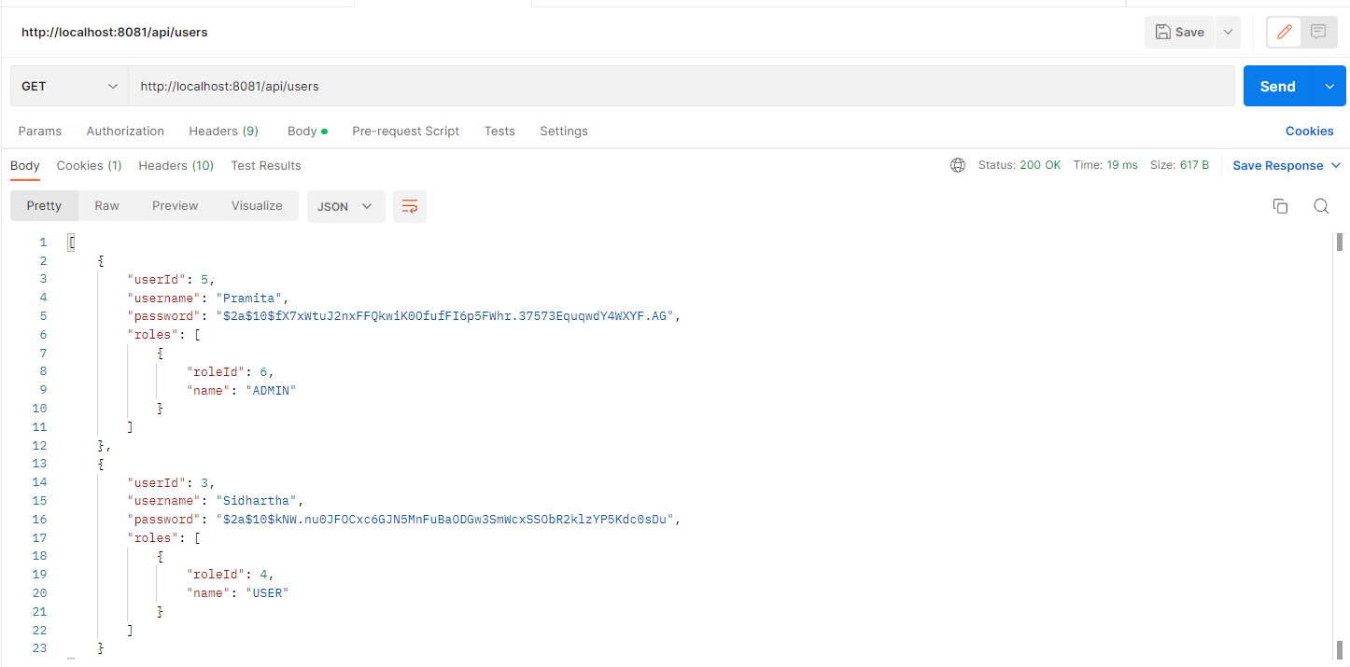

1. **Add Employees to the DB using a user having Admin role. The user has to be authenticated using Username and password in Postman**

The employees can be added/fetched from the end point

http://localhost:8081/api/employees

Here, in this example I’m using User: Pramita having admin role to POST employees

Authentication

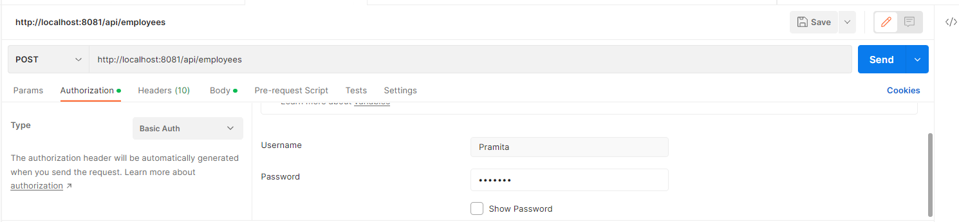

Posting Employees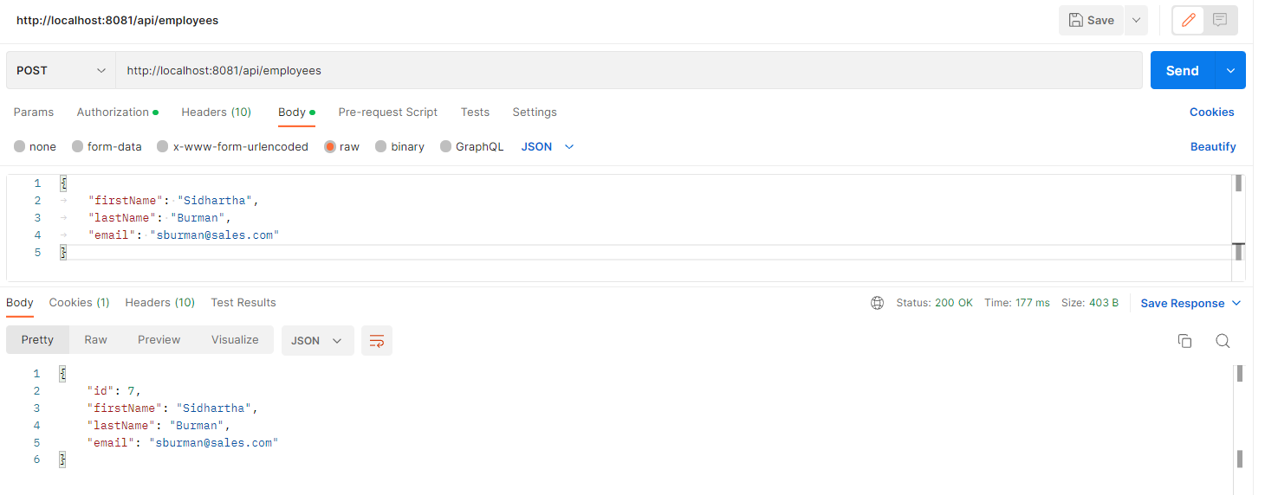

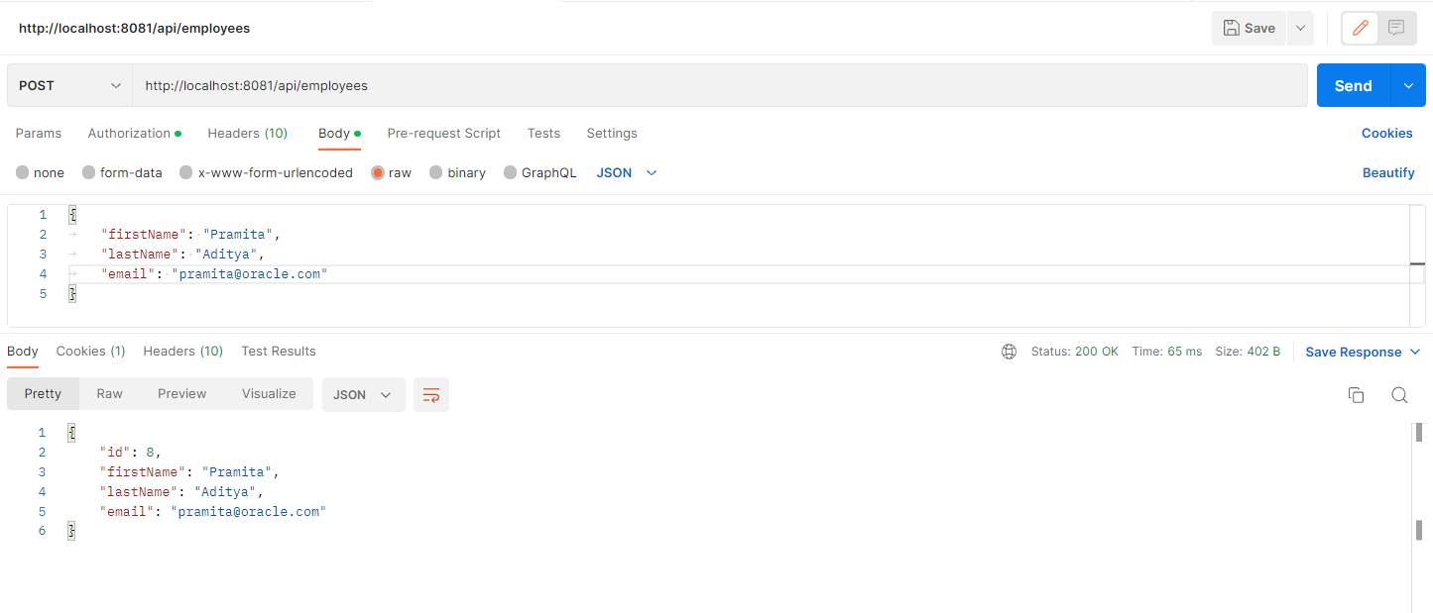

1. **List all the employees in the database**

The employees can be fetched from the endpoint

http://localhost:8081/api/employees

Fetching the added Employees using GET Method. This returns the employees added in Step 3 above.

Note : No authorisation is required to fetch the employees from the DB. It is an open end-point for fetching

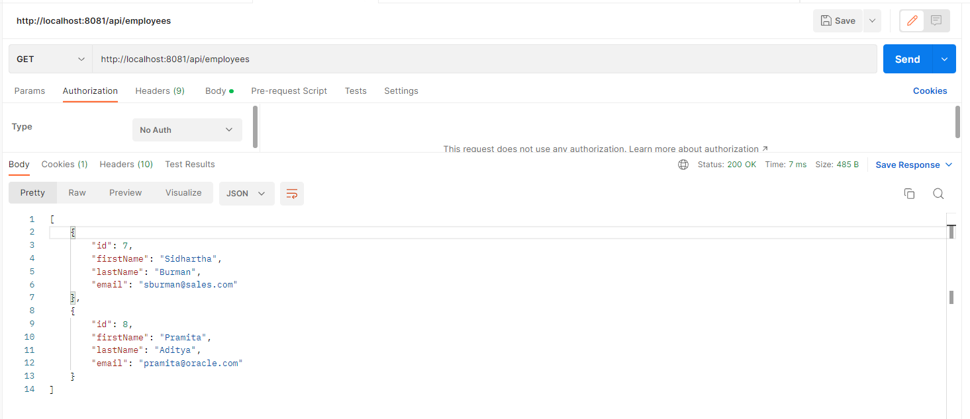

1. **Fetching an employee by Id**

An employee can be fetched by passing the employee id in the end point as shown below

<http://localhost:8081/api/employees/7>

Here, 7 is the employee id of the Employee: Sidhartha. So, hitting the above end-point will return details of employee Sidhartha.

Similarly, passing 8 as parameter to end-point will return details of Employee Pramita.

The above are demonstrated below.

Employee id: 7

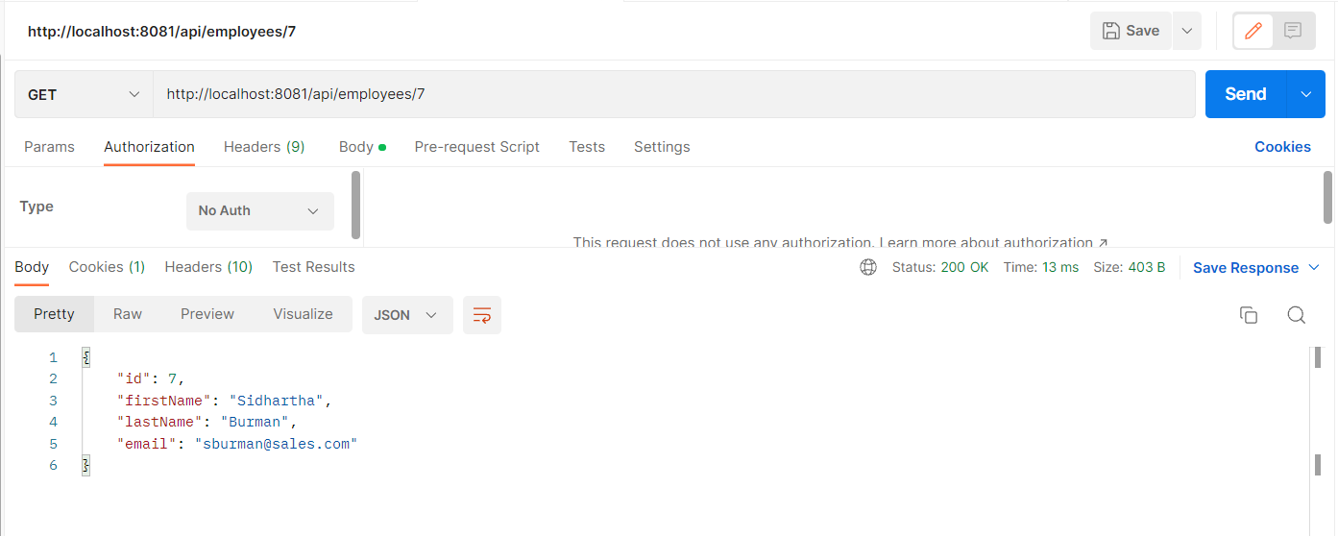

Employee id: 8

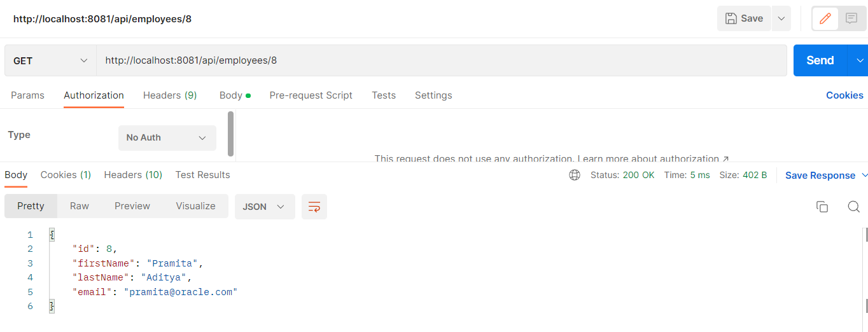

1. **Update an existing employee record with the given updated json object.**

An existing employee can be updated by passing the json object with employee id.

PUT request will need Authentication since it updates employee data. Have used the User: Pramita to update the same.

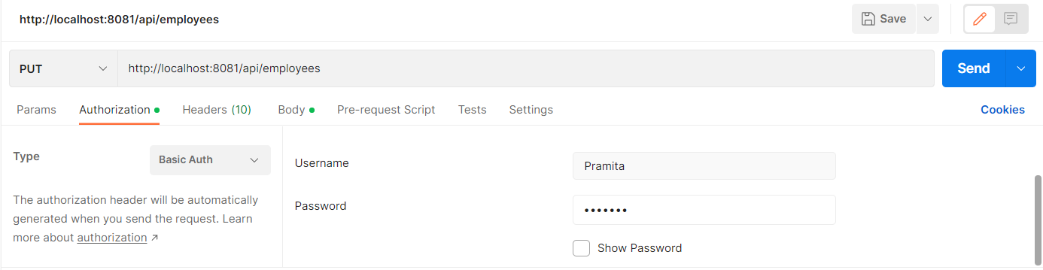

Updating the Employee Pramita’s email to pramita.aditya@oracle.com

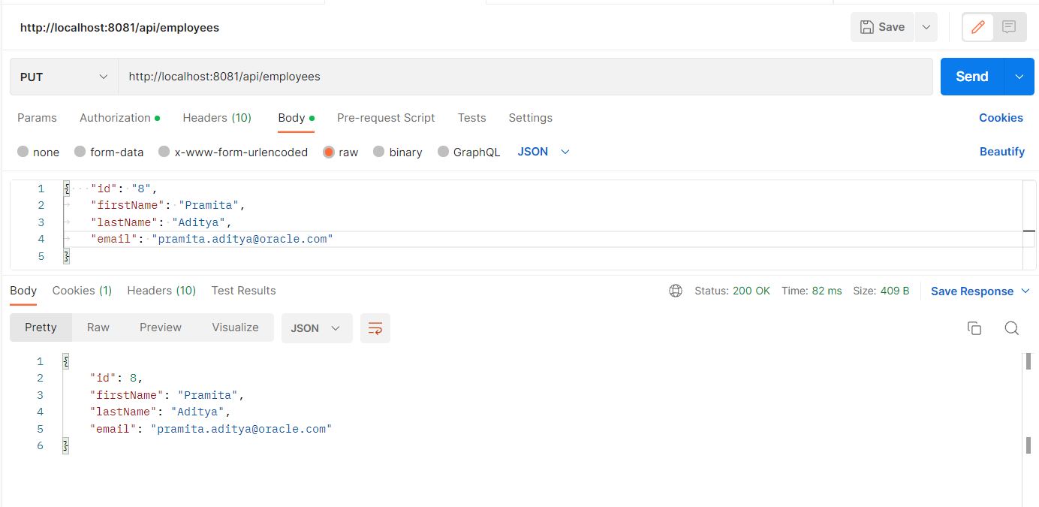

Fetching the updated Employee details using <http://localhost:8081/api/employees/8>

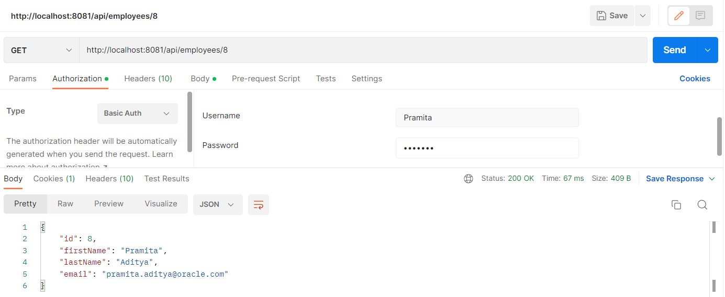

Similarly, updating Employee’s: Sidhartha lastname to : Dev Burman

Updating

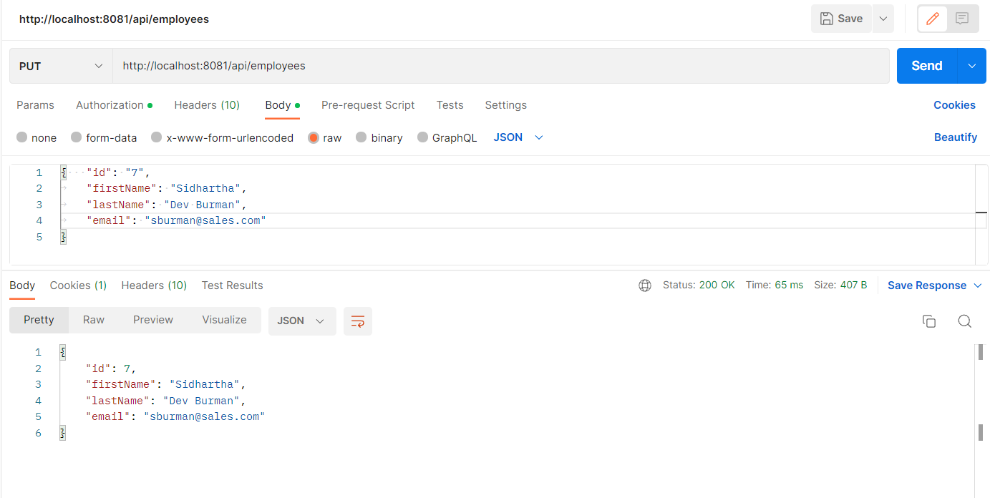

Fetching the updated employee

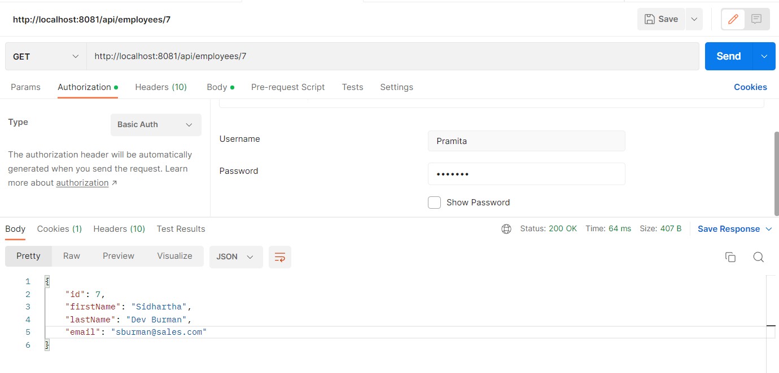

1. **Delete an existing employee**

An existing employee can be deleted by passing empid as a parameter and using DELETE method in postman as shown. The end point is :

http://localhost:8081/api/employees/7

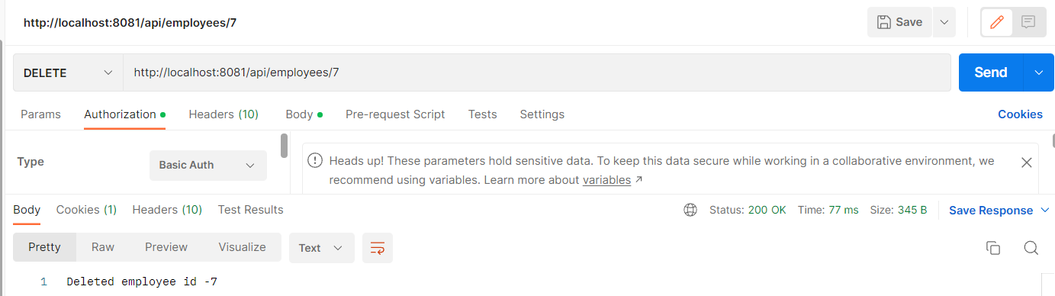

1. Fetching Employees by First Name

The endpoint for searching employees is

<http://localhost:8081/api/employees/search/Pramita>

Here, Pramita is the search parameter, i.e the Firstname

To demonstrate the above, creating 2 employees by firstname: Sandip

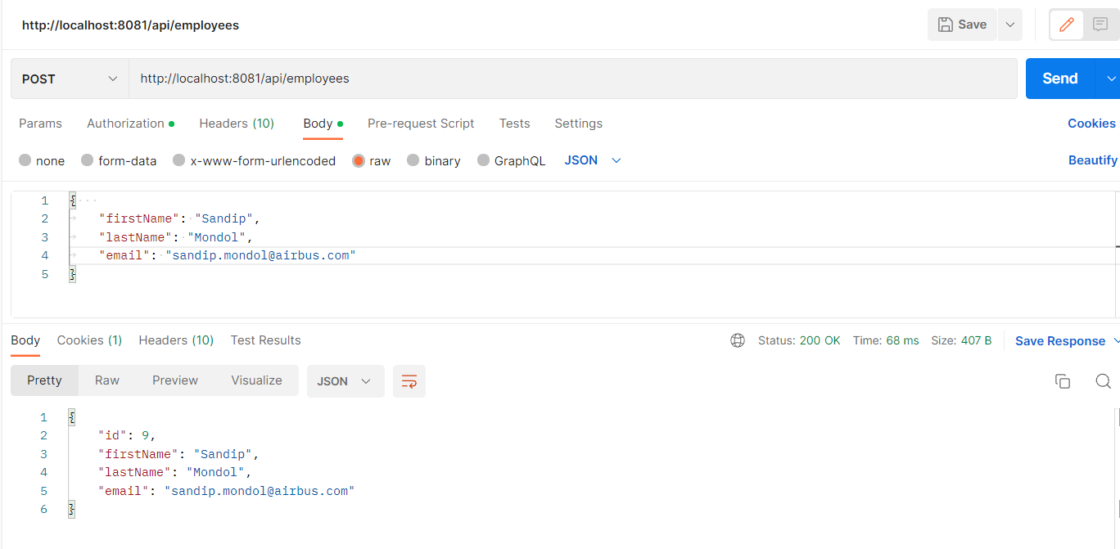

After addition of two employees, the GET fetches the below results

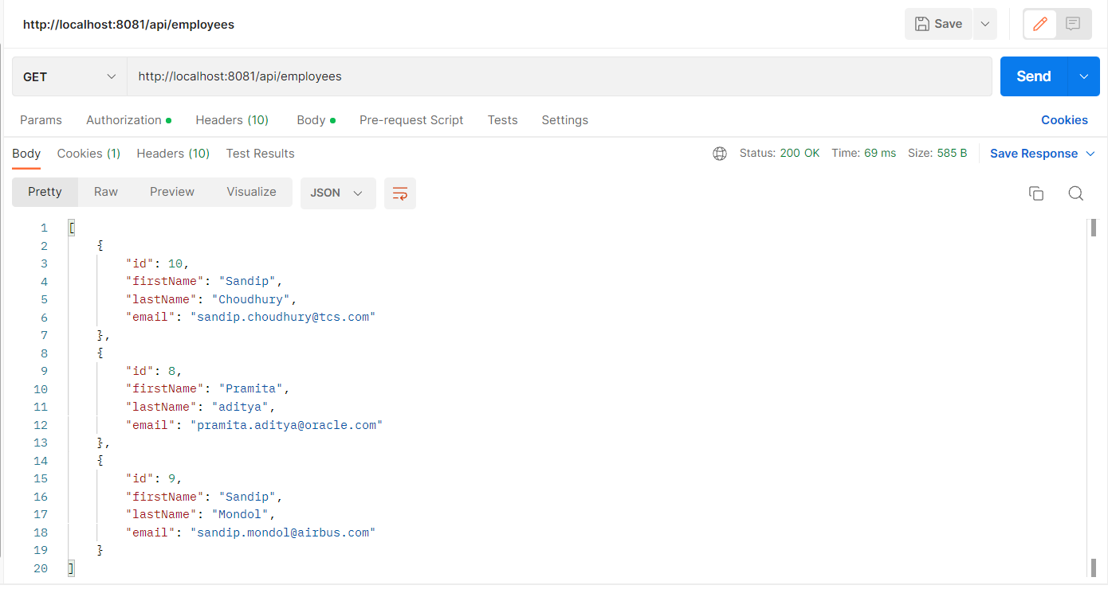

Now searching by Firstname: Sandip

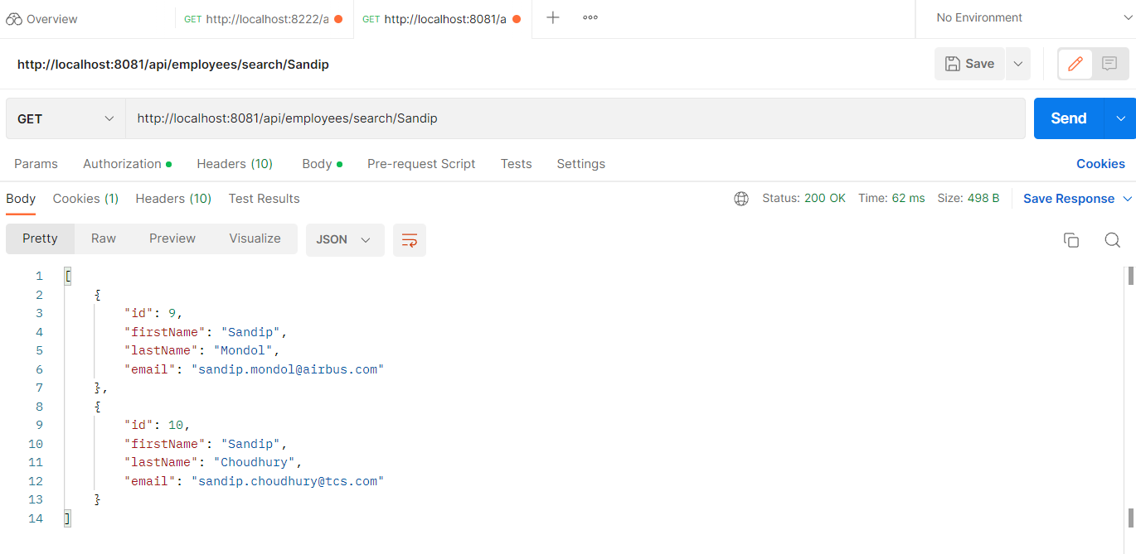

Now Searching by Firstname: Pramita

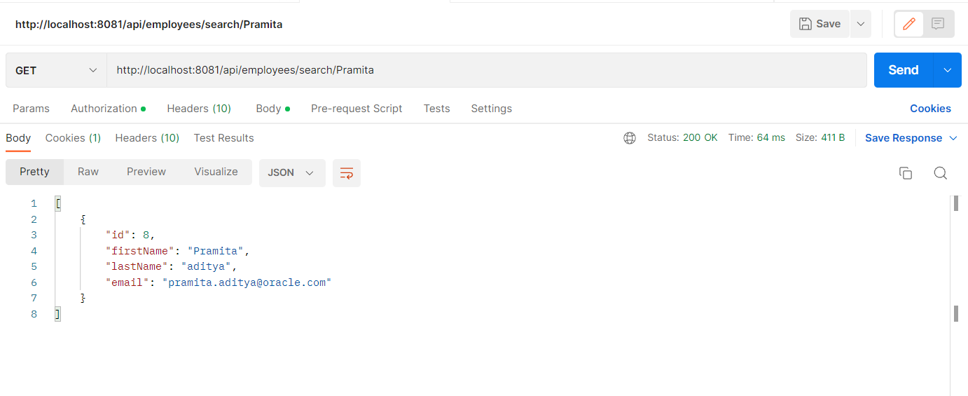

1. **Sorting Employees on First Name in Ascending or Descending order.**

Added few employees as shown below to test the Sorting end point. Employees fetched using GET

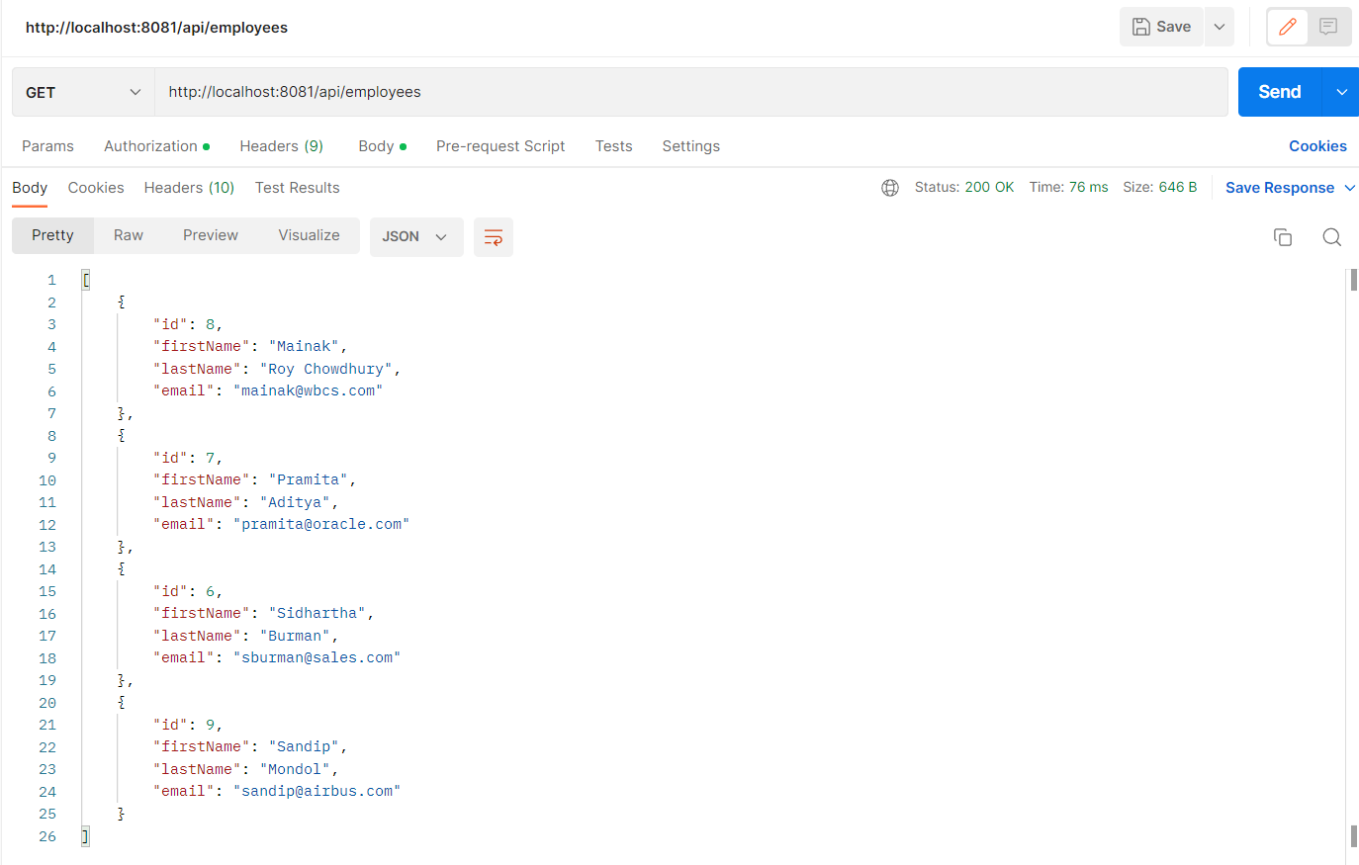

Endpoint for Sorting Employees by FirstName in Ascending order

http://localhost:8081/api/employees/sort/asc

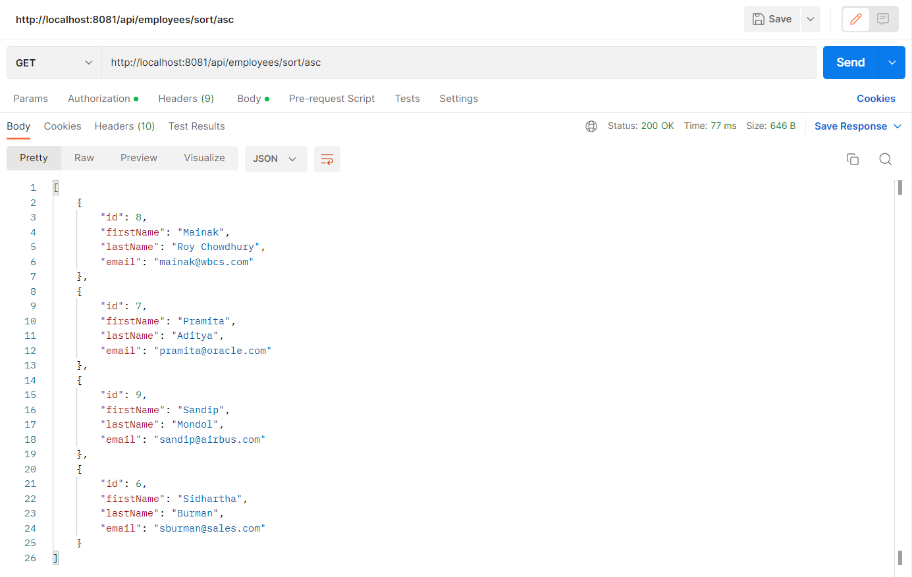

Endpoint for Sorting Employees by FirstName in Descending order

http://localhost:8081/api/employees/sort/desc

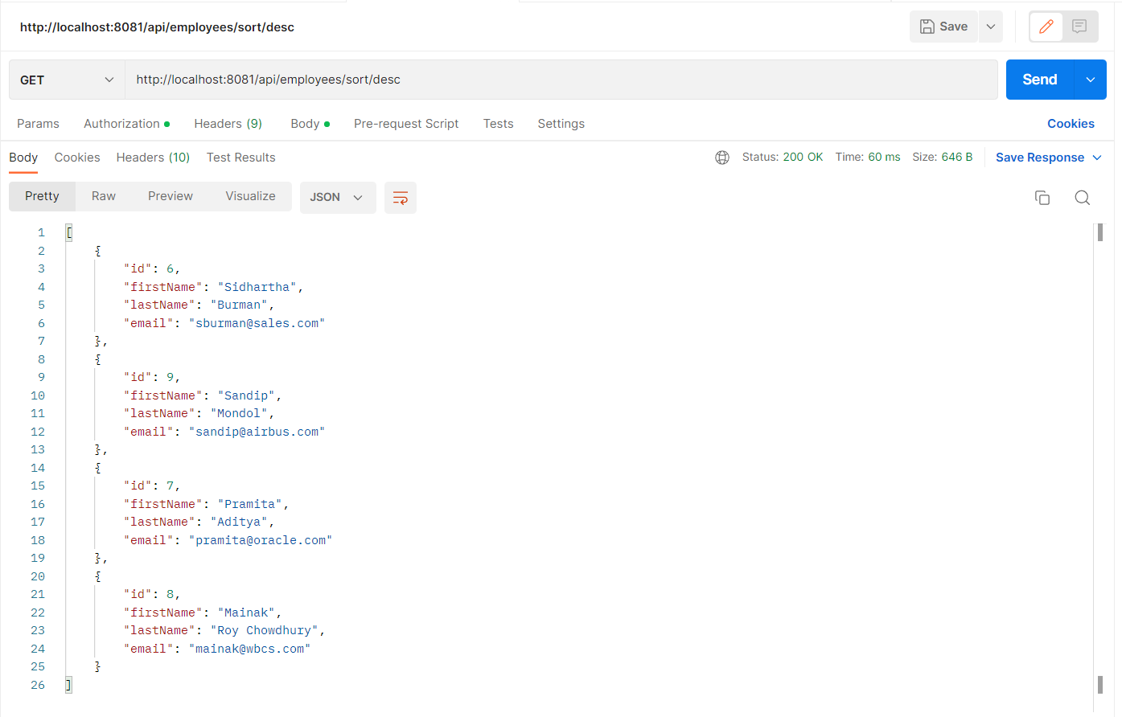

---END--